Last Updated: 07/11/2025

This QRG outlines the steps for requesting student data access for a position.
- Requests are initiated by the employee’s supervisor or business office.
  - An employee cannot request for themselves.

- A position number is needed when completing the request.
  - Position numbers are included in the employee’s profile or the Position Org Chart under My Company Info. Link to Org Chart

- The requestor must be on a VPN to connect to the SuccessFactors Employee Launchpad.
  - For help setting up a VPN, contact the IT Customer Service Center (West Lafayette Campus), Information Services (PNW Campus), or Technology Services (PFW Campus).

Access Role Request via SuccessFactors
From the OneCampus portal (https://one.purdue.edu/), launch Employee Launchpad – SuccessFactors.  Log in using Career Account and password. | 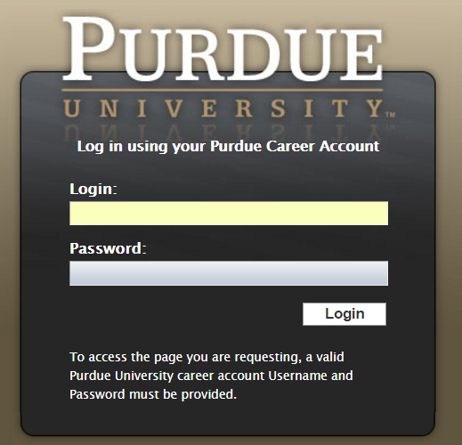
Under Organizational Updates on the SuccessFactors Home screen, click the Role Requests tile.
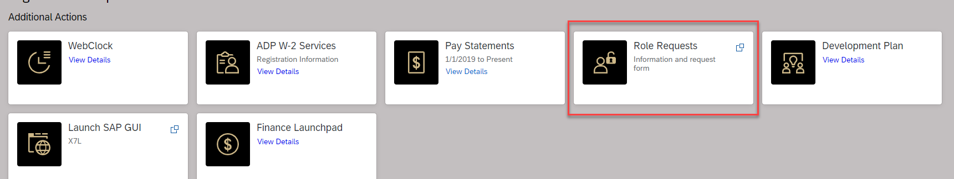
Click the blue IDM Role Request Form hyperlink.
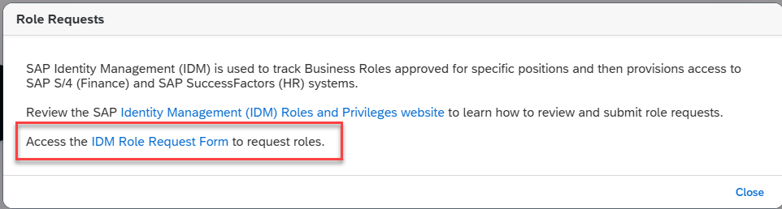
The request is displayed.  - Click Select (next to Position) to search for the employee’s position.  To find an employee’s position number, click here.  - Enter the position number in the Find text entry.  When searching, use an asterisk (*) before and after the term to perform a more accurate search.  - Click Search | 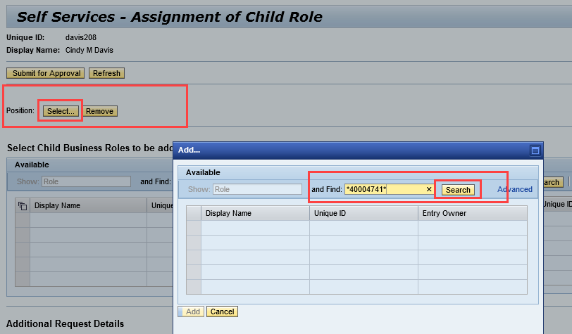
Click to select the desired position and click Add. If the position does not highlight, click the gray box to the left. | 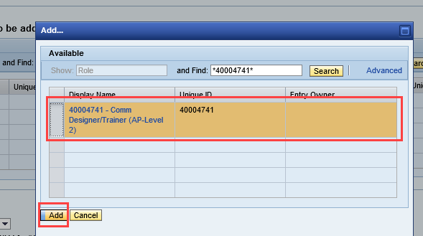
Select Add Role (or Remove Role, when applicable) from the Add or Remove menu under Additional Requests Details.  If restricting access to the role for a specific period of time, or delaying access to the role, enter Valid From and Valid To dates.  NOTE: The dates will apply to all roles on the request, so if one role should be limited, it should be requested separately. | 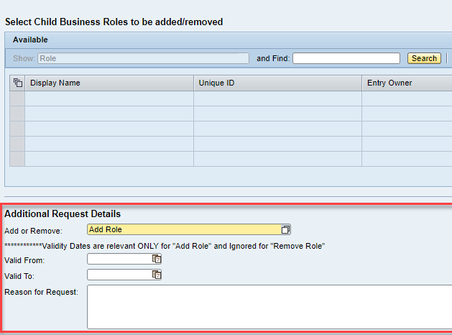
A Reason for Request should include:  - Name of the holder of the position, if applicable.  - Department  - If the position is grouped, note that here | 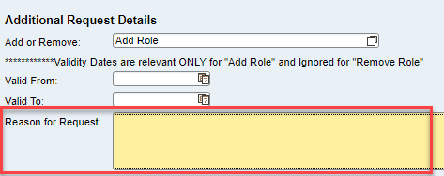
Locate the role by entering all or a portion of the role display name in the search information in the Find text entry field.  When searching, use an asterisk (*) before and after the term to perform a more accurate search.  Student Data:  *STU_DATA*  or  S4 - BI Dta BI270_000_STU_DATA_LEVEL1  Click Search. | 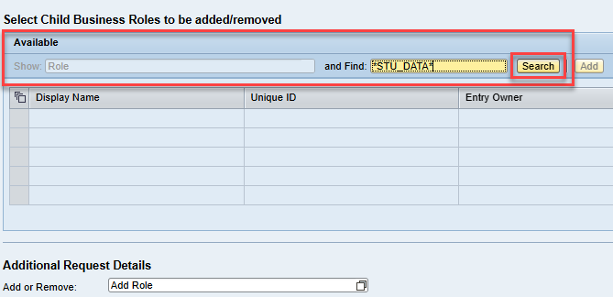
- Click to select desired role from search results within the Available table.
- Click Add to move to the Assigned table.
- Click Submit for Approval.

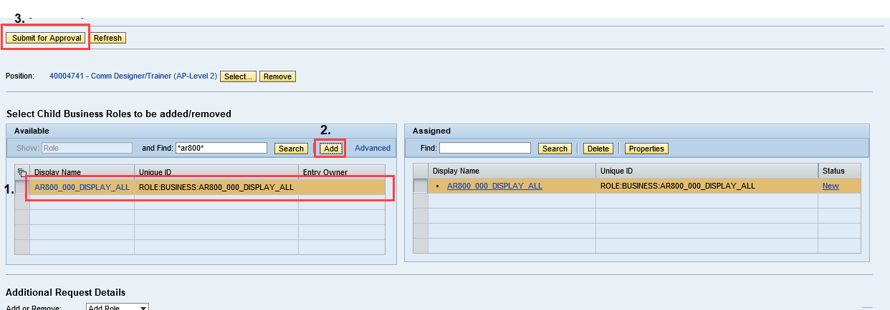

A message appears confirming the Child Role Assignment Request was Submitted. | 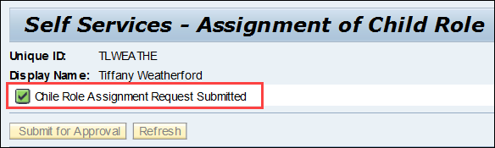

Who to Contact

If you have any questions regarding the student data request process, please contact bicc@purdue.edu.

Visit https://www.purdue.edu/bicc/data/student/access.php for more information regarding Cognos

Email Notifications
If approved, the requester receives an email that the selected role has been added to the selected position. | 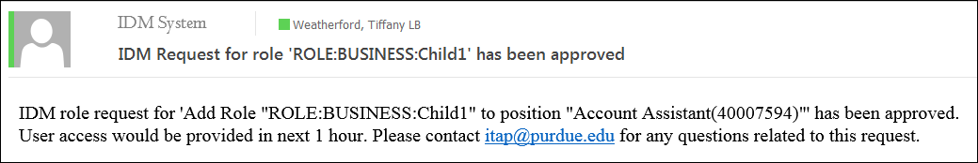
If denied, the requester receives an email stating that the selected role was denied | 